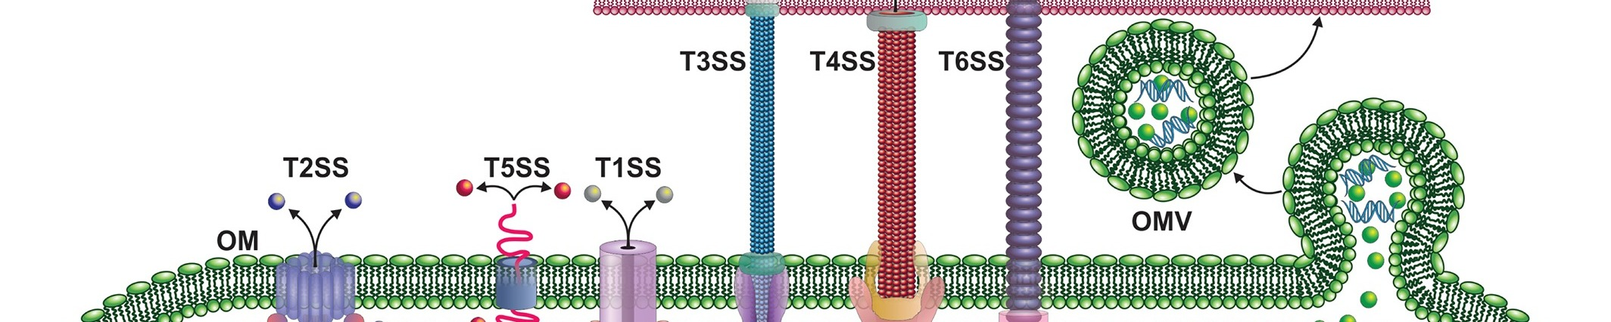COURSE SYLLABUS
BIOL 715 Microbial Physiology

Spring 2024

In person & Distance Learning course

Wednesdays 4:30-7:10 pm
School of Systems Biology,
College of Science, George Mason University

PROFESSOR: Dr. Monique van Hoek.
Office hours: By appointment
Email address: mvanhoek@gmu.edu (Important: Put “BIOL 715” in subject line).

SPECIAL NOTES:
Term: Wed Jan 17th, 2024 -Wed April 24th, 2024.
Spring Recess (no classes): Mon. Mar 4th - Sun. Mar 10th, 2024
Final Examination Period: Wed. May 1 - Wed. May 8th, 2024
Student Evaluations of Teaching/Course: Will be done online via Blackboard ~ mid-April.

COURSE DESCRIPTION
- Prerequisites: An undergraduate lecture/lab course in microbiology, and a course in biochemistry. This is NOT an introductory class in Microbiology.
- Course description from the university catalog: Comprehensive study of the functioning of microbial cells, with emphasis on bacterial pathogens. Growth, protein transport (secretion), cell-to-cell signaling, biofilm formation, antibiotic resistance, intracellular signaling, regulation of gene expression in bacteria and secondary metabolites will be stressed. Viral surface structures will also be explored.
- Course objectives: To introduce the student to more advanced concepts of the functioning of bacteria as realized by protein structures, with a focus on pathogenic bacteria. The relationship of microbial cell structure to function and the role of that function in physiology will be emphasized. Lectures will each cover a topic to give students a deep understanding of the particular topic. Student presentations and assignments will further explore specialized topics in microbial physiology.
- Assigned readings and video presentations are a requirement for this class. Assigned readings will cement the concepts and facts and are covered by the exams.
- Peer-to-Peer: Students must also comment on other students’ paper presentations for points towards participation grade.
- Paper Presentations: One or two pertinent published papers will be discussed following most lecture topics, emphasizing to the student current research in that particular area of microbial physiology. Each student must present their assigned paper on the assigned date or negotiate an alternative paper, presentation mode or date in advance with the instructor. The number of presentations per week and per student will depend on the number of students enrolled.
- Homework: Additional activities for grades may include worksheets, quizzes, a class blog or other small assignments.

REQUIRED ASSIGNEMNTS:
1. Readings: Students will need to read any assigned material before the designated class period. Reminders will be sent, but it is the student’s responsibility. Lightening quizzes may occur.
2. Presentations: Students will give 1-2 paper presentations on an assigned paper. Each paper will be presented by one or a pair of students, depending on enrollment (30 minutes long). Other non-presenting students are expected to read the assigned presentation papers before class and be prepared to discuss them following the presentation.
3. Peer evaluation: Students will evaluate their peer’s paper presentations. The student DOING the evaluation will get a point for completing this task for each presenter. The presenting student will receive an evaluation that combines student and instructor evaluation into one score. Feedback comments may be provided back to the student in an anonymized fashion.
4. Other Homework: Blog posts, quizzes, worksheets, etc as assigned.
5. EXAMS:
1. Midterm Exam or Assignment.
2. Final Exam or Assignment.

GRADING: OVERALL GRADE:
Class Presentation 20%
Participation/Commenting 10%
Homework, Quizzes, etc. 15%
Midterm 25%
Final Exam 30%
TOTAL POINTS= 100%

Grade breakdown:

Letter Grade | Percent Grade | Letter Grade | Percent Grade | Letter Grade | Percent Grade
A+ | 97-100 | B | 83-86 | C- | 70-72
A | 93-96 | B- | 80-82 | D+ | 67-69
A- | 90-92 | C+ | 77-79 | D | 65-66
B+ | 87-89 | C | 73-76 | E/F | Below 65

REQUIRED TEXTS:
- None to purchase. We will use the online textbook, Bacterial Pathogenesis, plus papers.
- There is required reading of assigned papers
- You should plan to read as much background material as needed for your level of knowledge. You might need to read a lot.

SUGGESTED TEXTS
- Bacterial Pathogenesis: A Molecular Approach, Fourth Edition, 2019. Brenda A. Wilson Available online free via GMU Library.
- https://wrlc-gm.primo.exlibrisgroup.com/permalink/01WRLC_GML/1prj2t5/alma9947119172504105
- The Physiology and Biochemistry of Prokaryotes. White, D. Oxford University Press. New York, NY. On reserve at SciTech Library Reserve Desk.

TENTATIVE CLASS LECTURE AND PRESENTATION SCHEDULE - TBA
Note: Special Lecture dates with invited speakers are TBD depending on speaker’s schedules.
Note: The number of presentations and homework assignments will be adjusted according to the class size.

Office Hours: Tuesdays at 7 pm via a link I will share, or by email appointment TBD.

Other Academic Policies: All GMU academic policies will be followed.
Plagiarism: Plagiarism is not acceptable, and assignments may be subject to manual or computer scanning for plagiarized material. This includes all written assignments and plagiarism from AI assistants. Assignments with plagiarized material will receive a score of ZERO.
GMU Honor Code: The integrity of the University community is affected by the individual choices made by each of us. Mason has an Honor Code with clear guidelines regarding academic integrity. Three fundamental and rather simple principles to follow at all times are that: (1) all work submitted be your own; (2) when using the work or ideas of others, including fellow students, give full credit through accurate citations; and (3) if you are uncertain about the ground rules on a particular assignment, ask for clarification. No grade is important enough to justify academic misconduct. Plagiarism means using the exact words, opinions, or factual information from another person without giving the person credit. Writers give credit through accepted documentation styles, such as parenthetical citation, footnotes, or endnotes. Paraphrased material must also be cited. A simple listing of books or articles is not sufficient. Plagiarism is the equivalent of intellectual robbery and cannot be tolerated in the academic setting. If you have any doubts about what constitutes plagiarism, please consult your professor.
GMU Student Resources & Disability Services: If you are seeking accommodations for this class, please first visit https://ds.gmu.edu/ for detailed information about the Disability Services registration process. Then please discuss your approved accommodations with me after class or by email. If you need other assistance or support, please consult the GMU Provost (provost.gmu.edu) or College of Science (cos.gmu.edu) for additional services.

